**Appendix B. Rainfall Data**

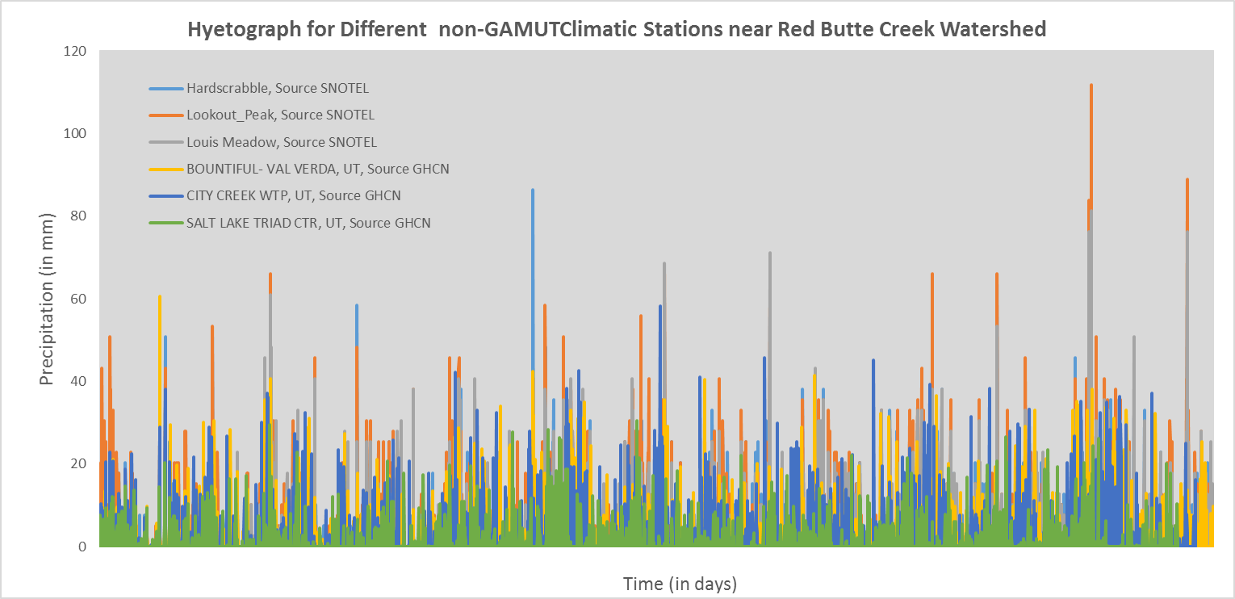

5/29/2012

01/01/2000

Figure 7. Showing precipitation records for six climatic non-GAMUT stations near the Red Butte Creek Watershed. The figure shows that the Salt Lake Triad Center source gives us the least rainfall among the six, while the Lookout Peak seem to give the largest rainfall.

Figure 8. Showing precipitation records for six climatic GAMUT stations in the Red Butte Creek Watershed. The figure shows that the station located in the Green Infrastructure (site code: RB_GIRF) gives the least rainfall among the six, while the Lookout Peak seem to give the largest rainfall.